AWS LAB - 4: Working with EBS

Vishakha Maruti Sonmore (CSULB ID: 032188141)

College of Business, California State University, Long Beach

Course Number: I S 602 Sec08 12348 Management Information Systems

Instructor: Dr. Santos Galvez

Due date: 11-Nov-2023

**Lab 4: Working with EBS**

This lab focuses on Amazon Elastic Block Store (Amazon EBS), a key underlying storage mechanism for Amazon EC2 instances. In this lab, you will learn how to create an Amazon EBS volume, attach it to an instance, apply a file system to the volume, and then take a snapshot backup.

Start the Lab

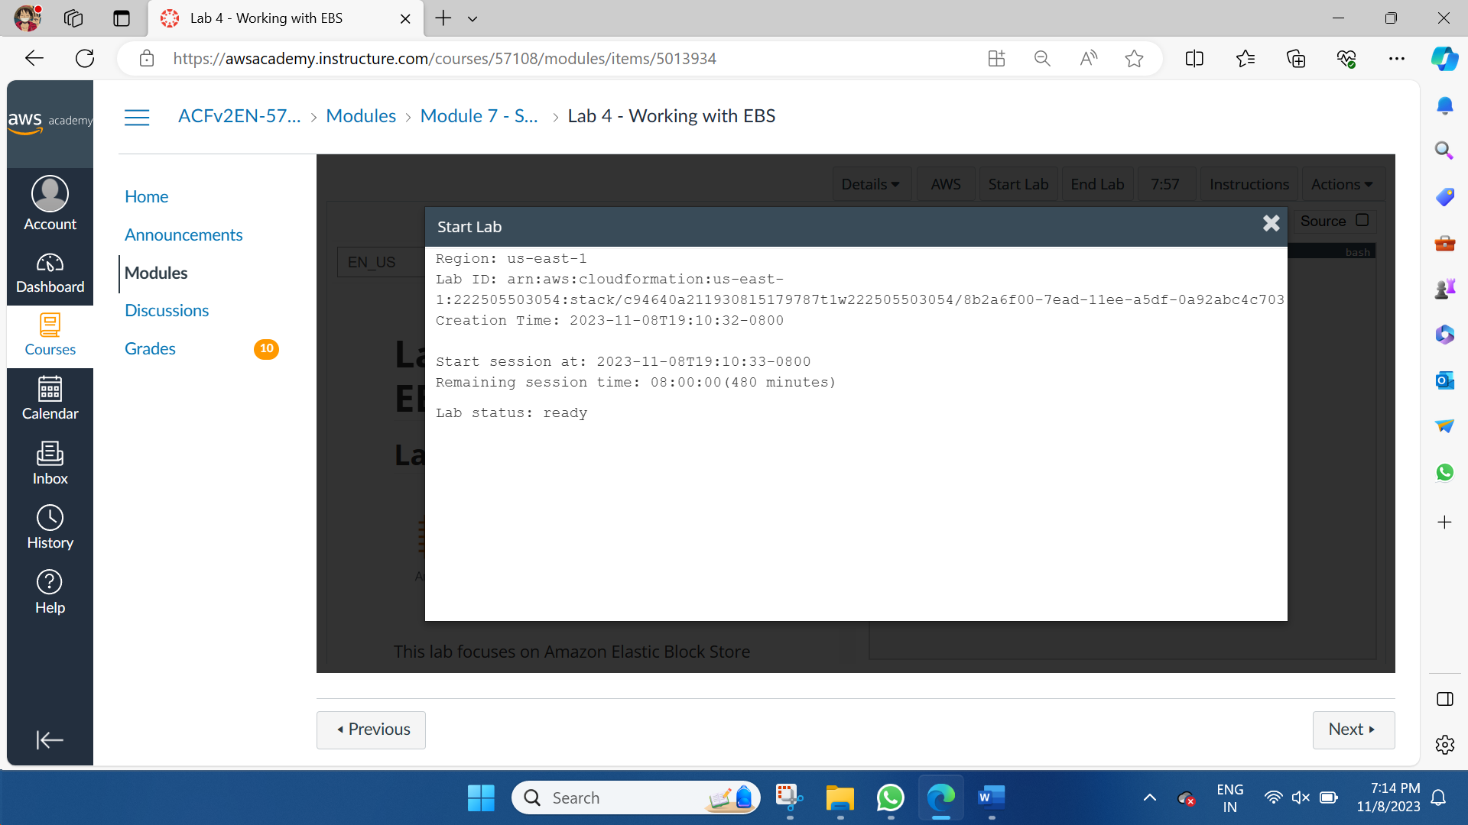

**Task 1: Create a New EBS Volume**

In the **AWS Management Console**, on the **Services** menu, click **EC2**.

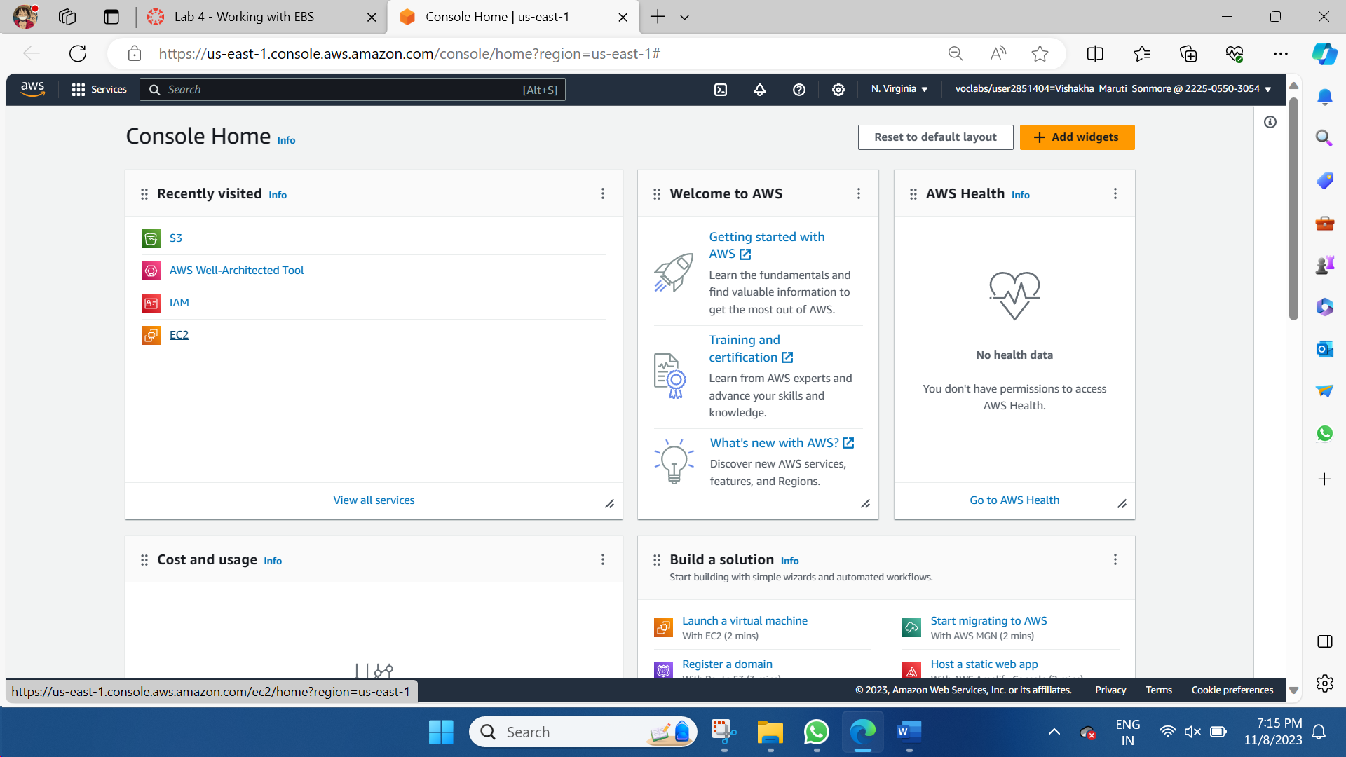

In the left navigation pane, choose **Instances**. An Amazon EC2 instance named **Lab** has already been launched for your lab.

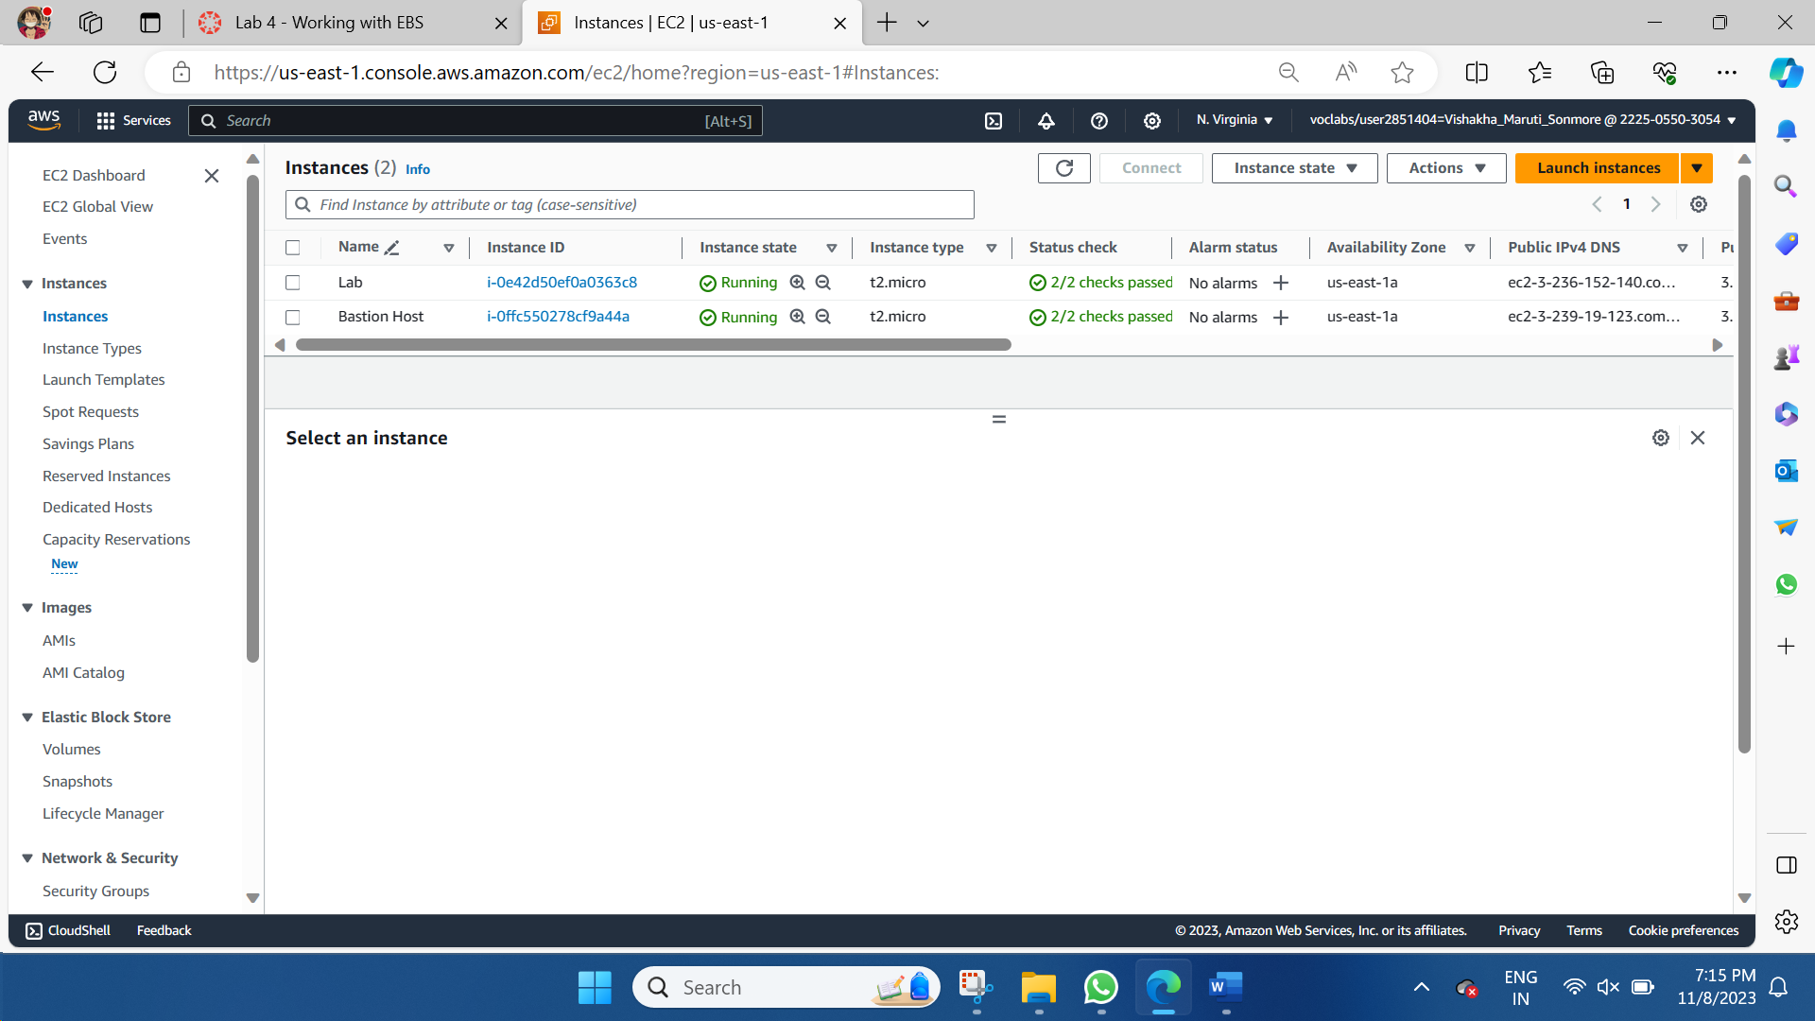

Choose **Create volume** then configure:

* + **Volume Type:** *General Purpose SSD (gp2)*
  + **Size (GiB):** 1. **NOTE**: You may be restricted from creating large volumes.
  + **Availability Zone:** Select the same availability zone as your EC2 instance.
  + Choose **Add Tag**
  + In the Tag Editor, enter:
    - **Key:** Name
    - **Value:** My Volume

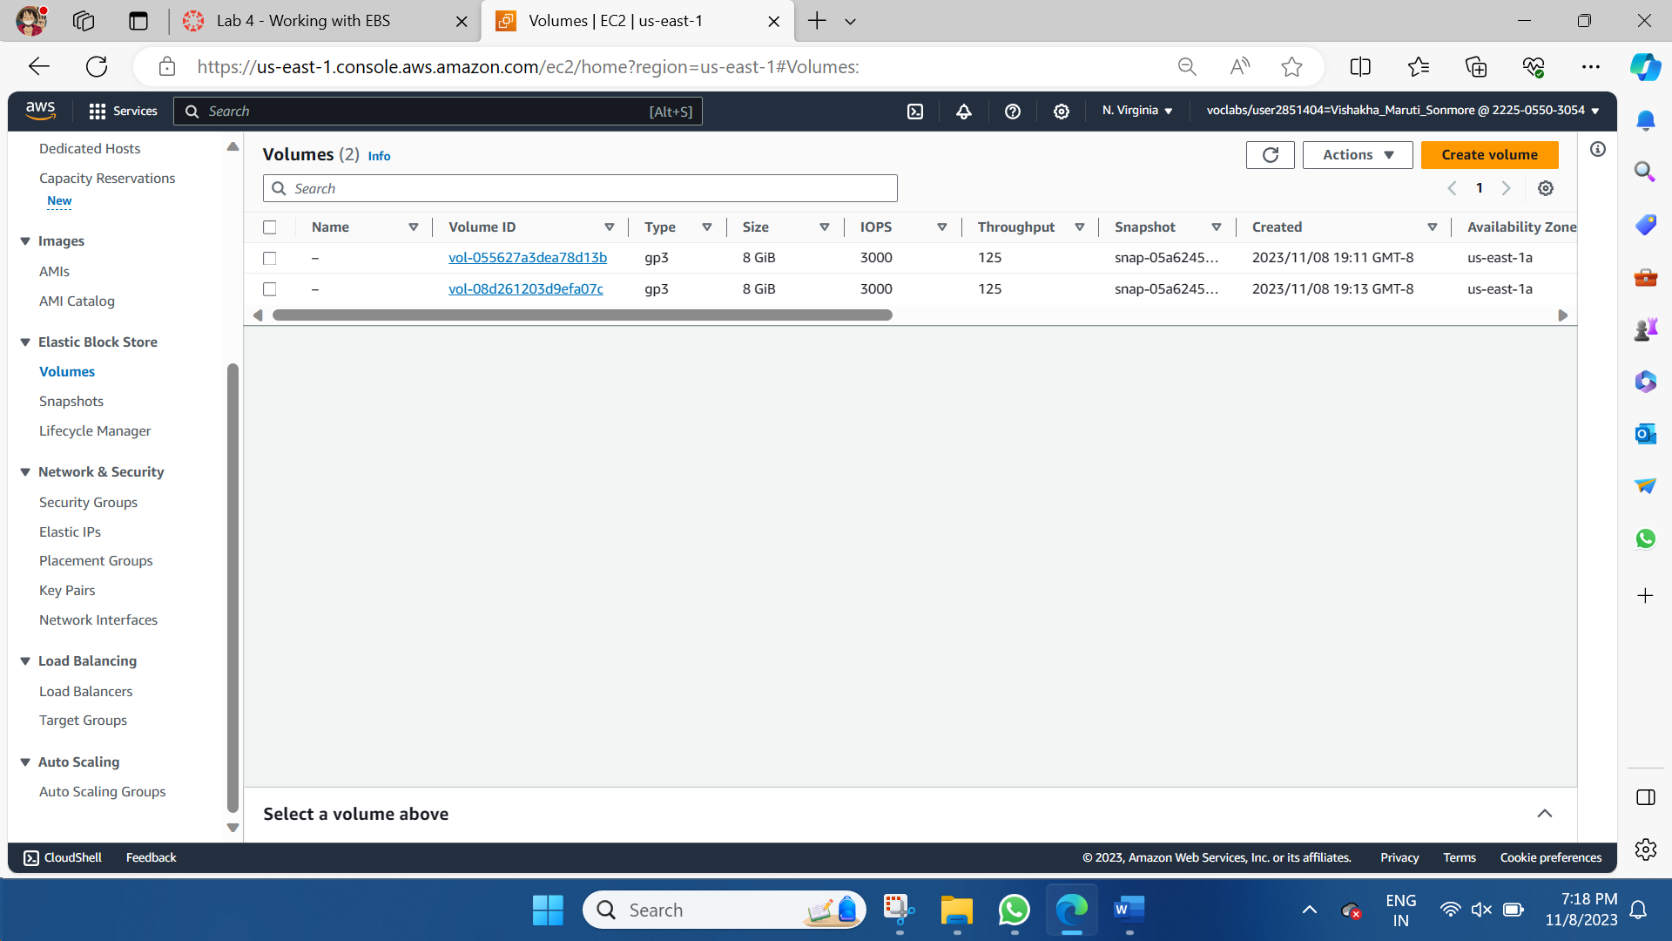

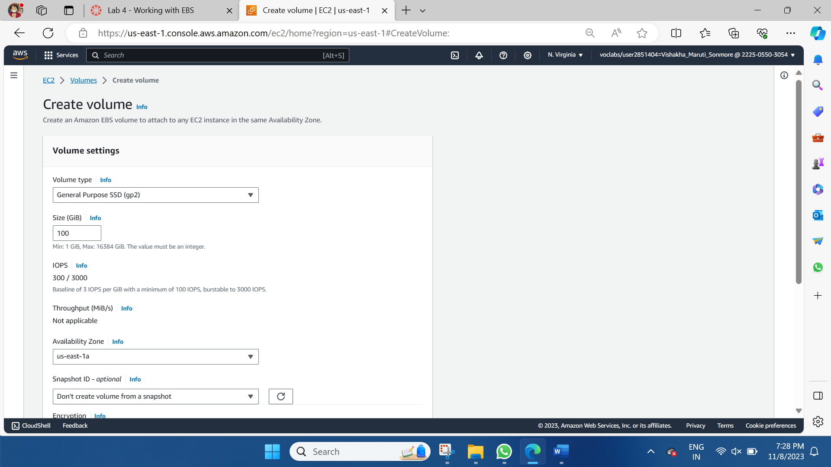

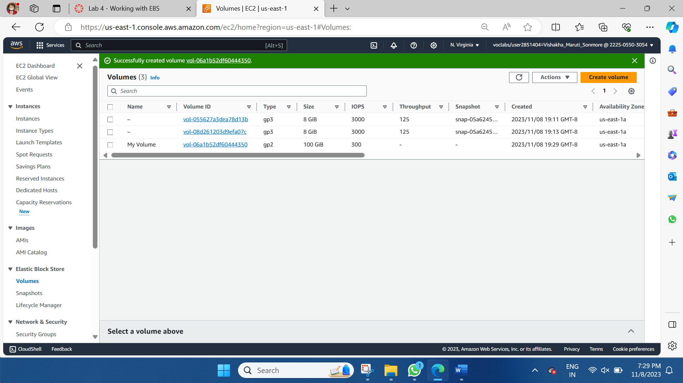

**Task 2: Attach the Volume to an Instance**

Select **My Volume** >> In the **Actions** menu, choose **Attach volume**.

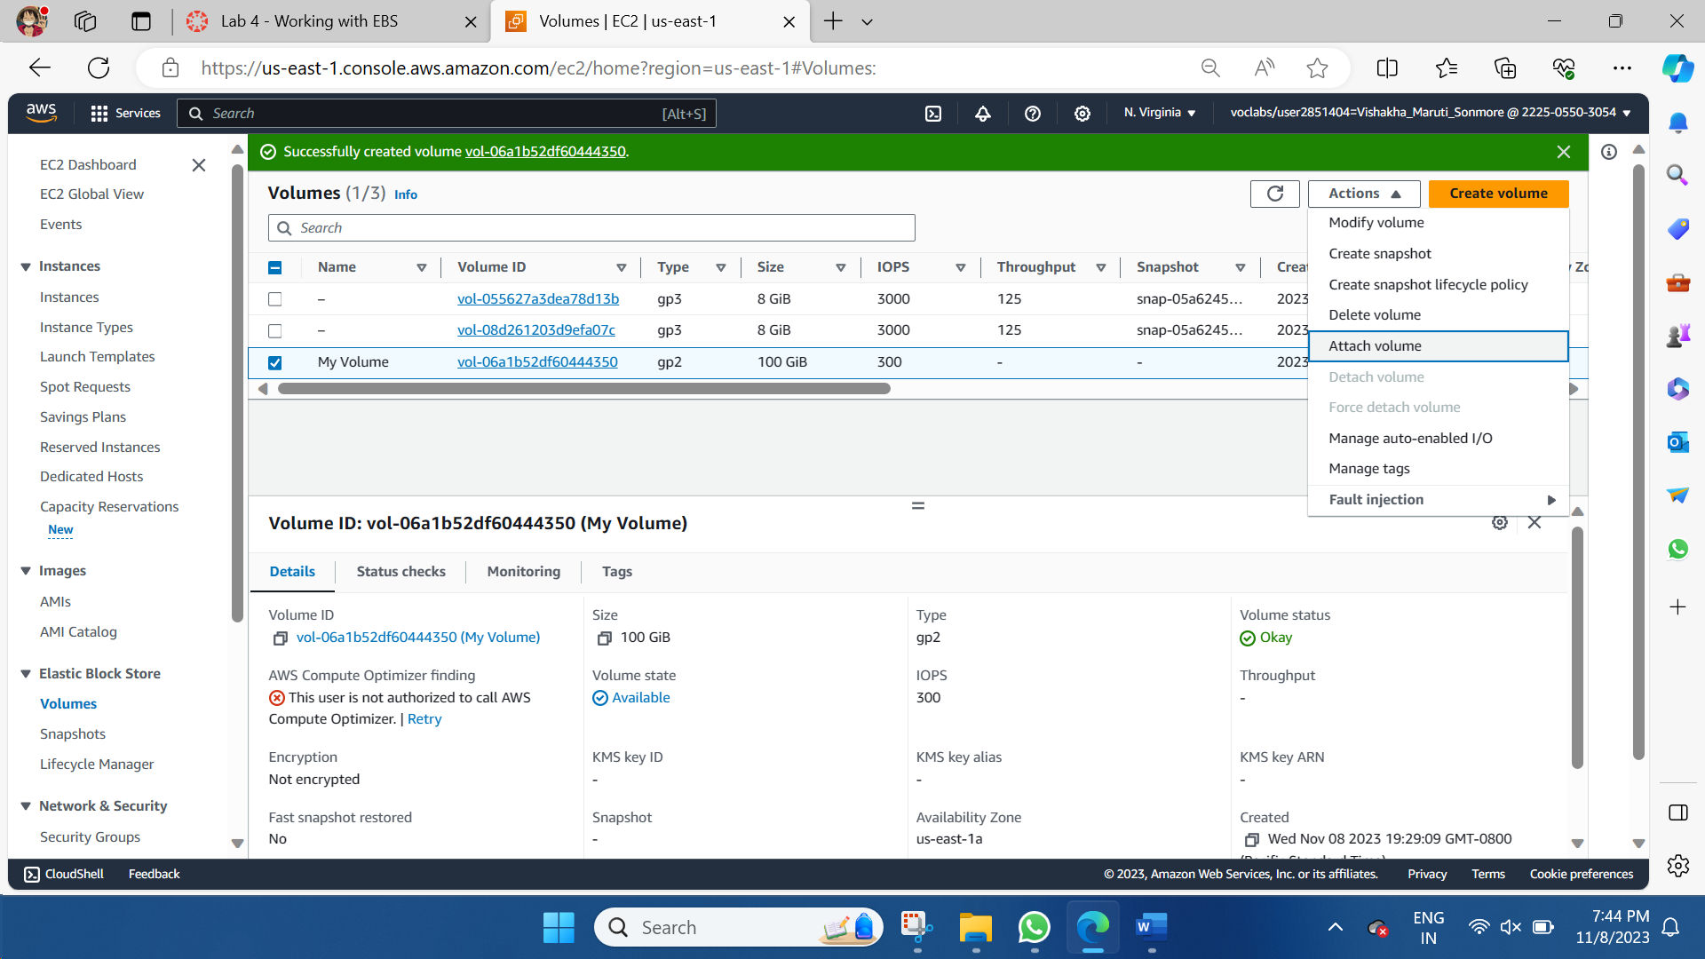

Choose the **Instance** field, then select the instance that appears (Lab).

Note that the **Device** field is set to */dev/sdf*. You will use this device identifier in a later task.

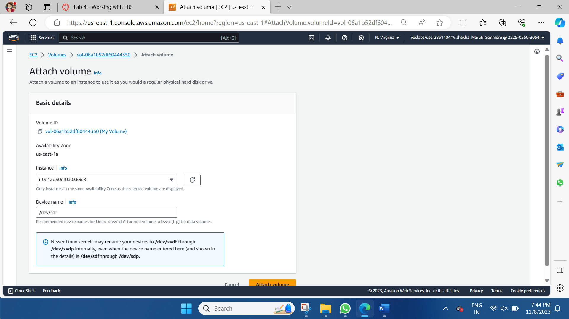

Choose **Attach volume** The volume state is now

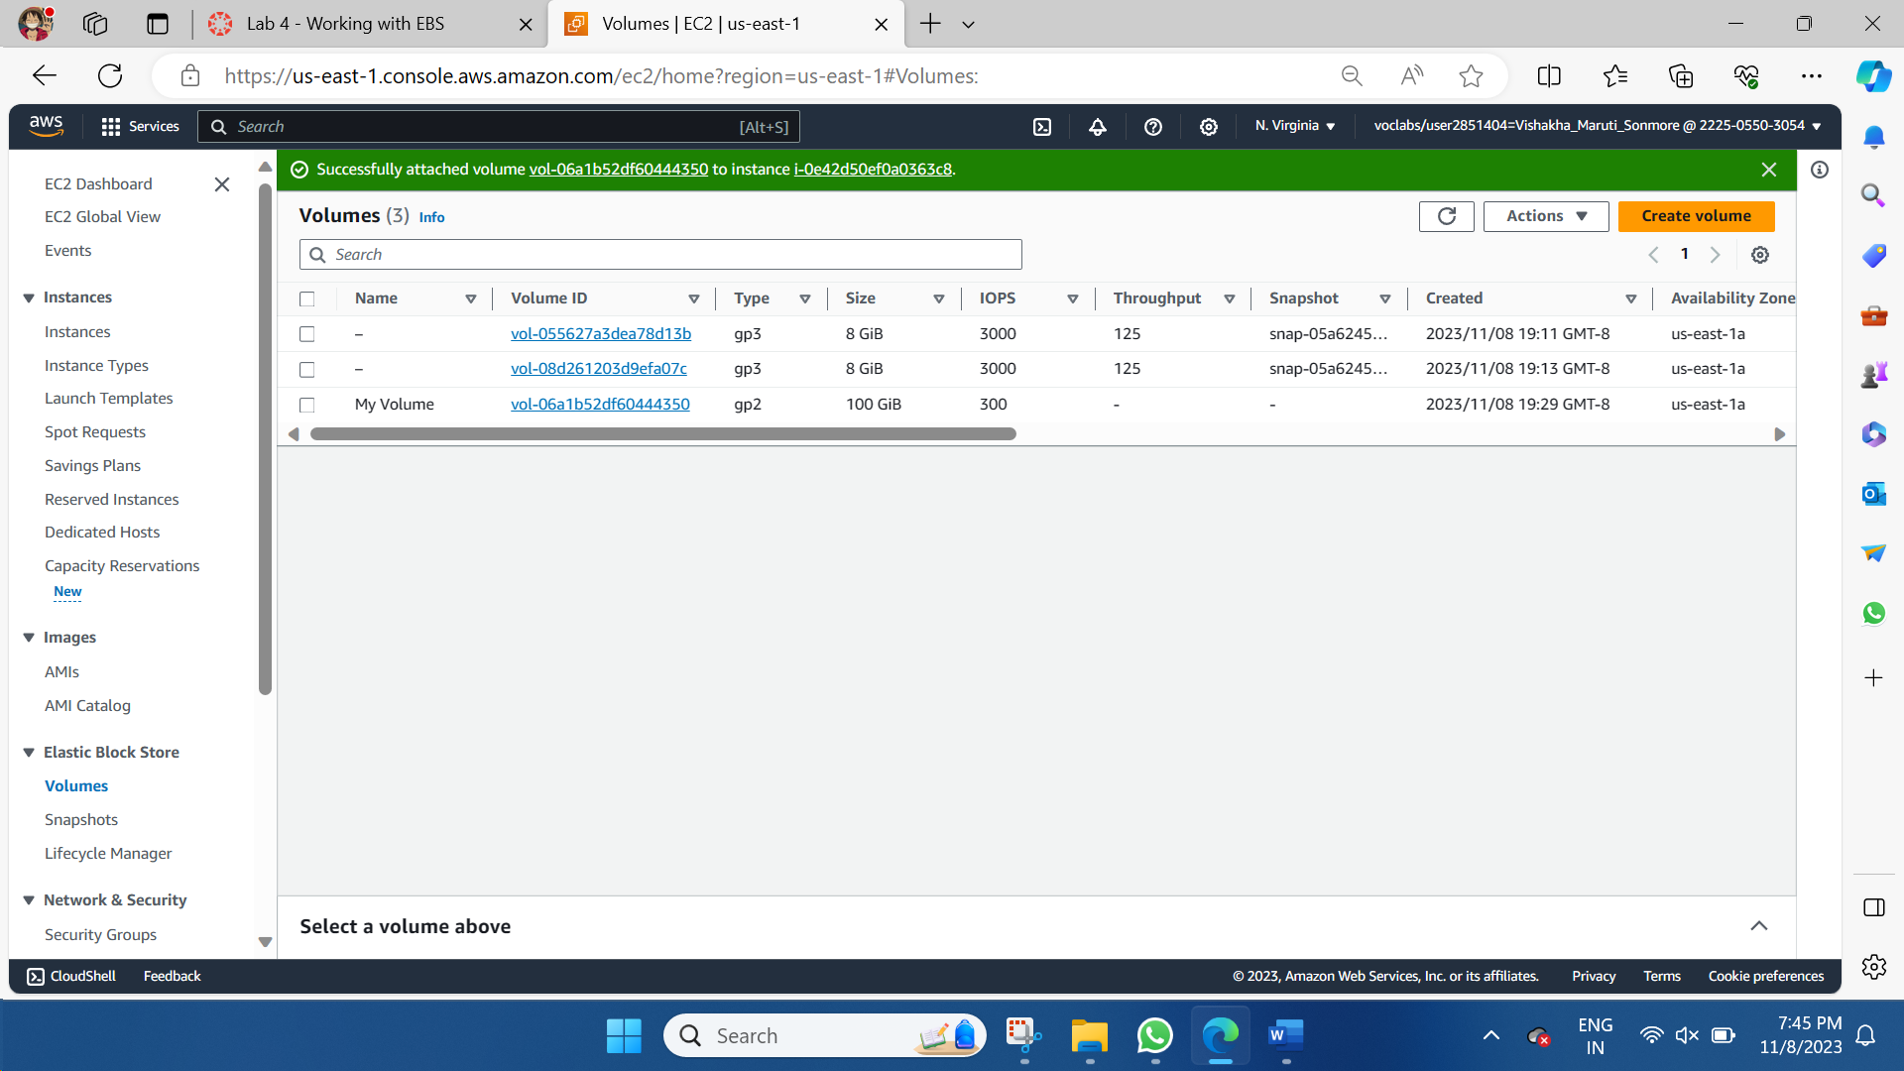

**Task 3: Connect to Your Amazon EC2 Instance**

* Choose the Details drop down menu above these instructions you are currently reading, and then choose Show. A Credentials window will open.
* Choose the **Download PPK** button and save the **labsuser.ppk** file. Typically, your browser will save it to the Downloads directory.
* Then exit the Details panel by choosing the **X**.

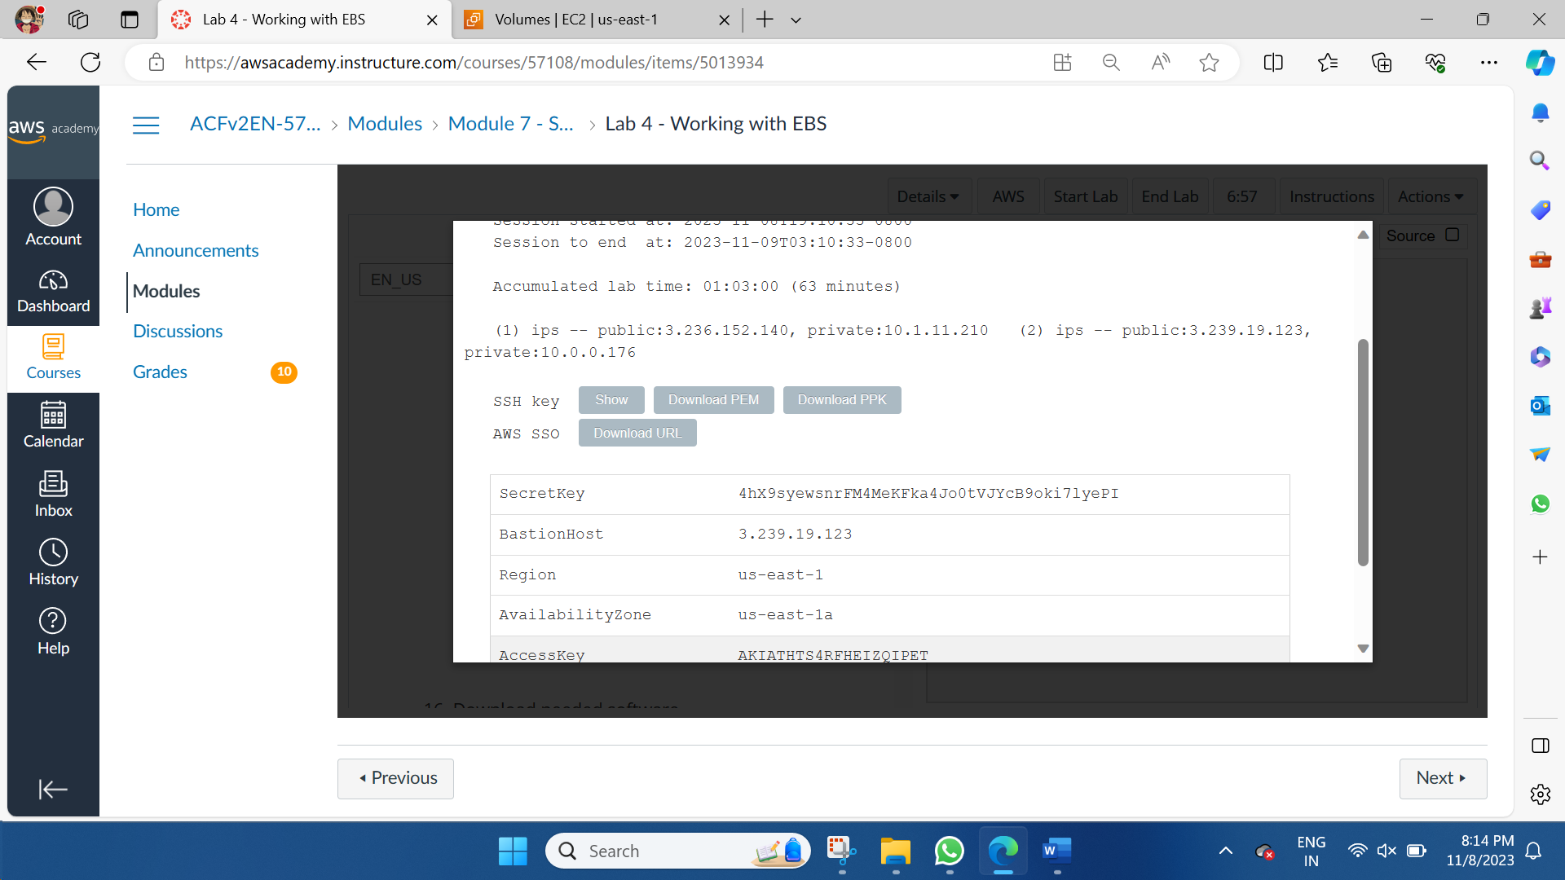

* Download needed software. Configure PuTTY to not timeout, this allows you to keep the PuTTY session open for a longer period of time.
* Choose **Connection**
* Set **Seconds between keepalives** to 30
* Open **putty.exe >>** Configure PuTTY to not timeout:
* Choose **Connection**
* Set **Seconds between keepalives** to 30
* Configure your PuTTY session:
* Choose Session
* Host Name (or IP address): Paste the Public DNS or IPv4 address of the Lab instance that you noted earlier.
* Back in PuTTY, in the Connection list, expand SSH
  + Choose **Auth** and expand **Credentials**
  + Under **Private key file for authentication:** Choose **Browse**
  + Browse to the *labsuser.ppk* file that you downloaded, select it, and choose **Open**
  + Choose **Open** again
* To trust and connect to the host, choose **Accept**.
* When prompted **login as**, enter: ec2-user

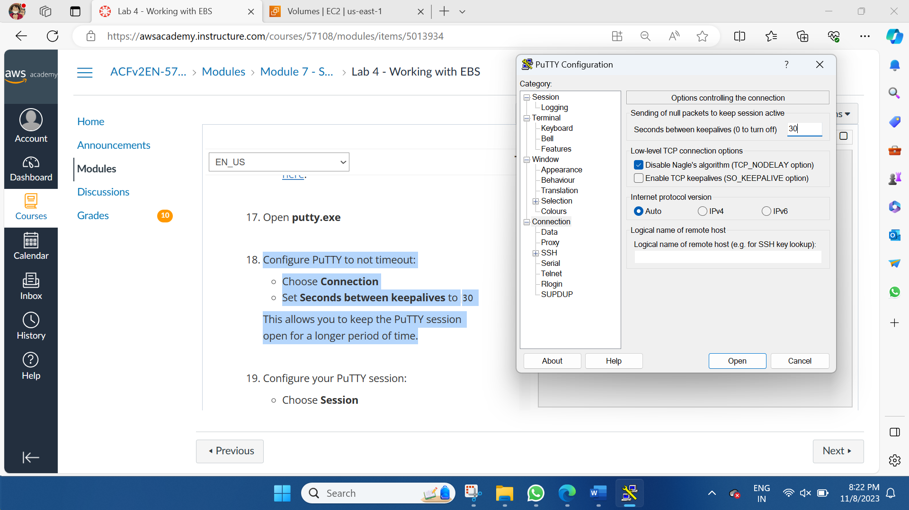

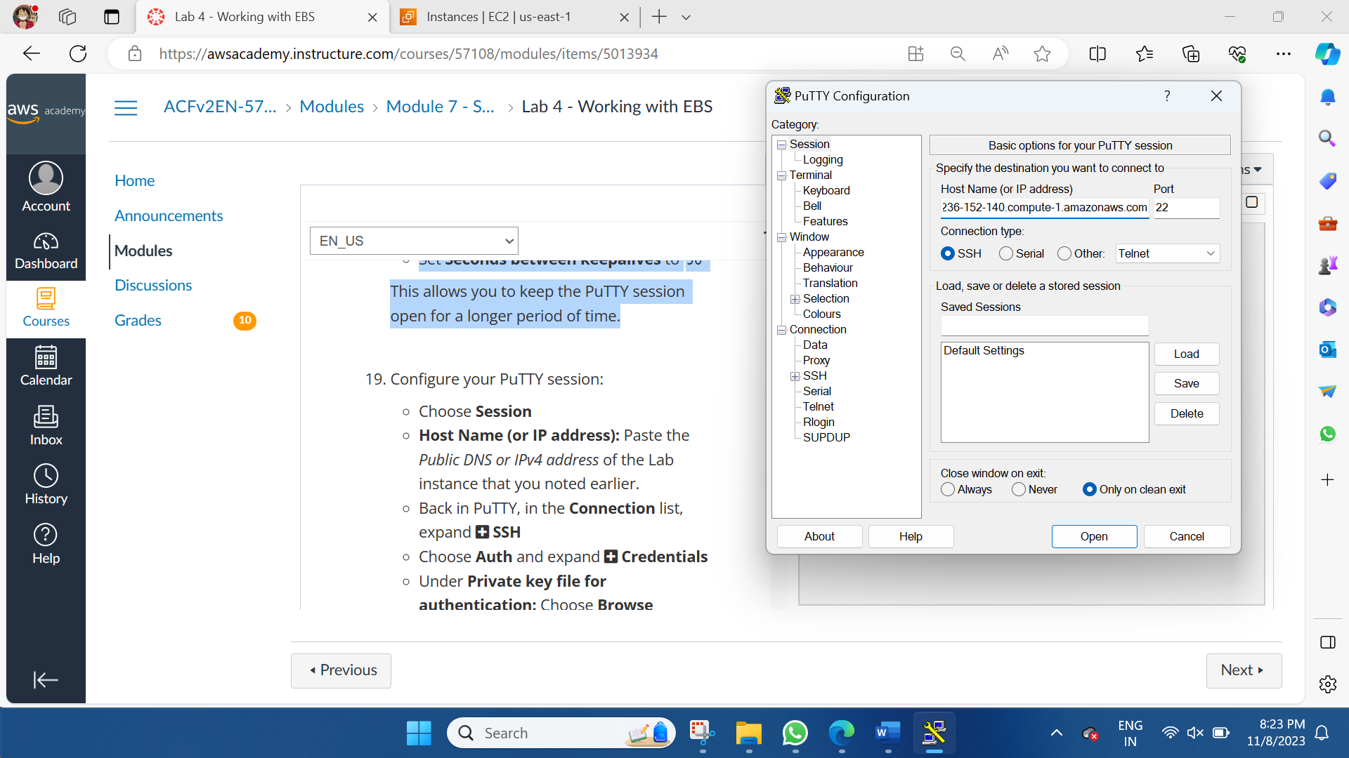

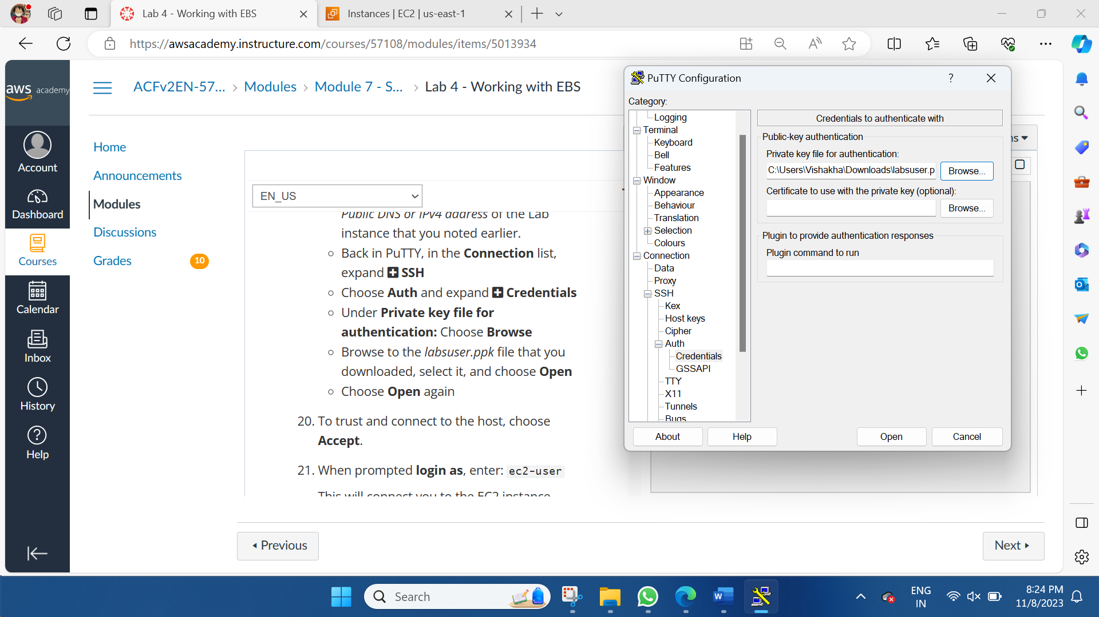

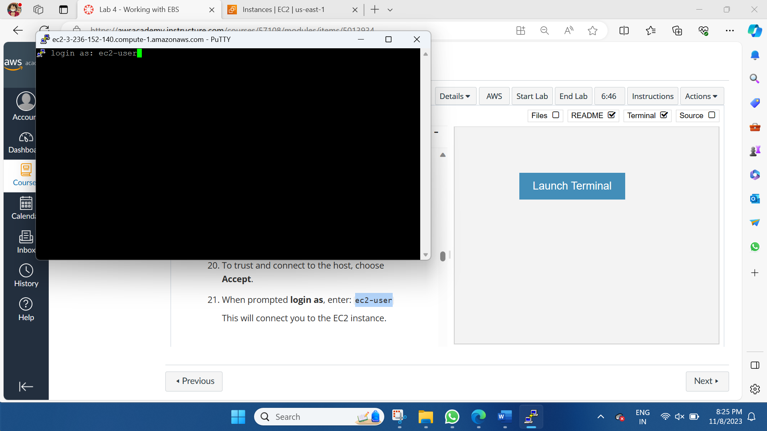

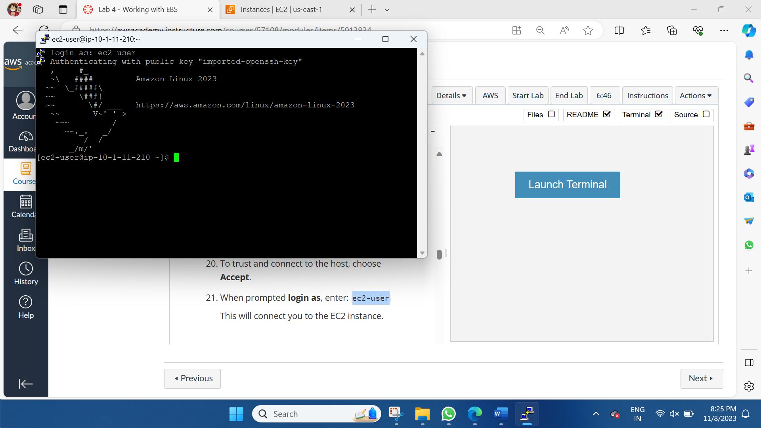

**Task 4: Create and Configure Your File System**

In this task, we will add the new volume to a Linux instance as an ext3 file system under the /mnt/data-store mount point.

View the storage available on your instance:1

df -h

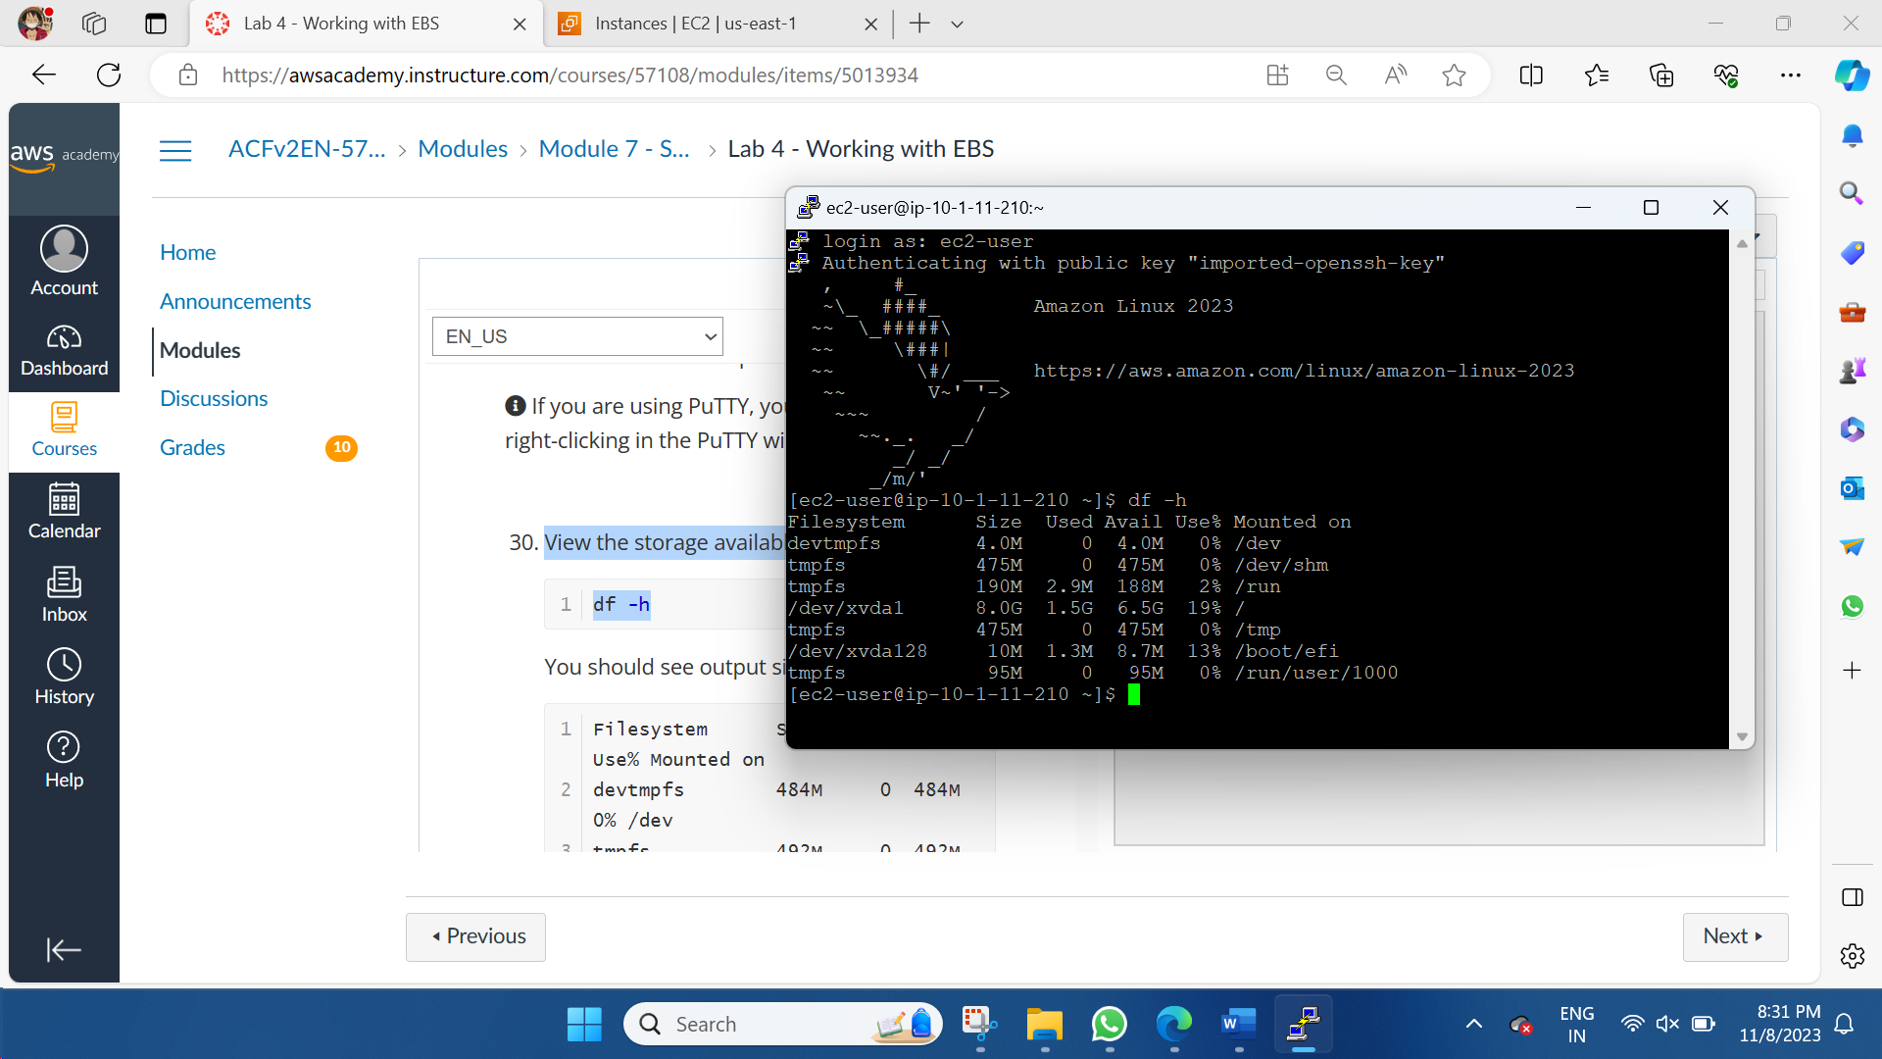

Create an ext3 file system on the new volume:1

sudo mkfs -t ext3 /dev/sdf

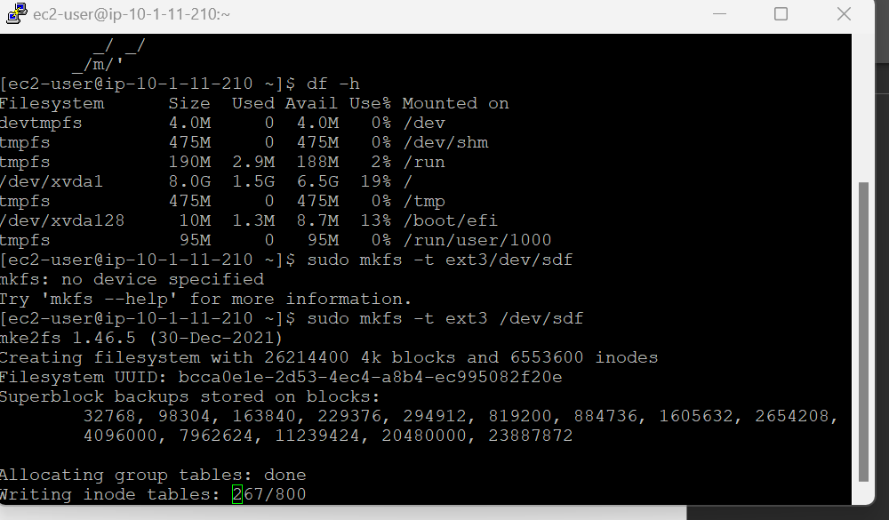

Create a directory for mounting the new storage volume1

sudo mkdir /mnt/data-store

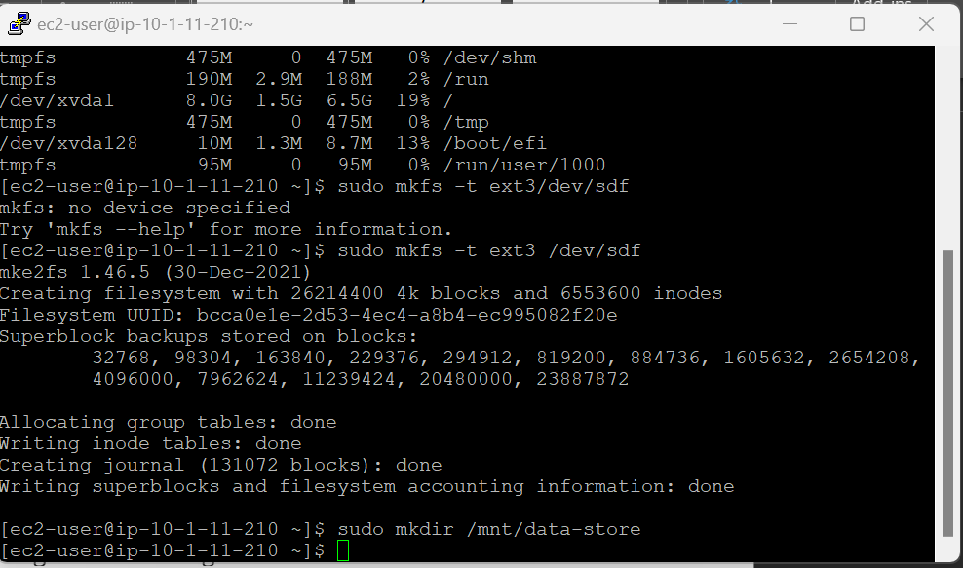

Mount the new volume:1

sudo mount /dev/sdf /mnt/data-store

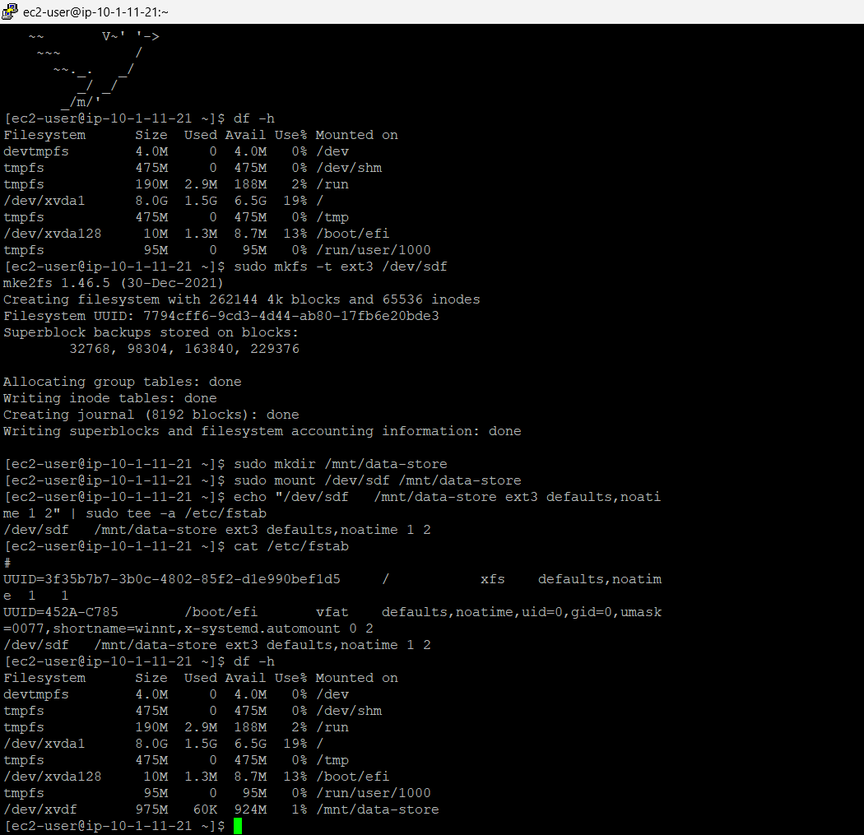

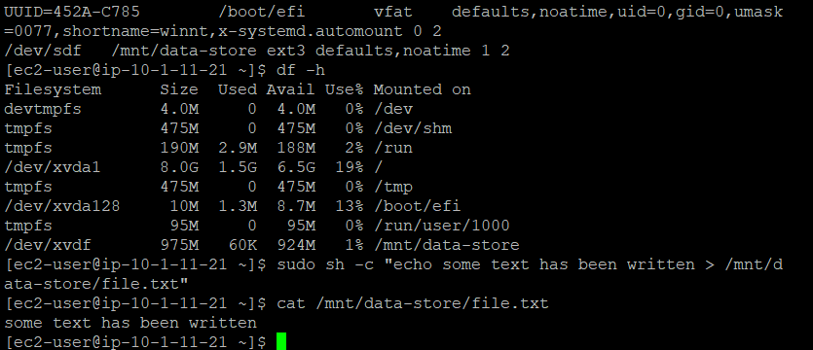

**Task 5 - Create an Amazon EBS Snapshot**

Creating snapshot of the volume

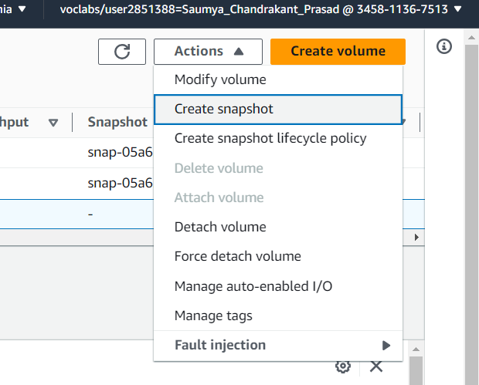

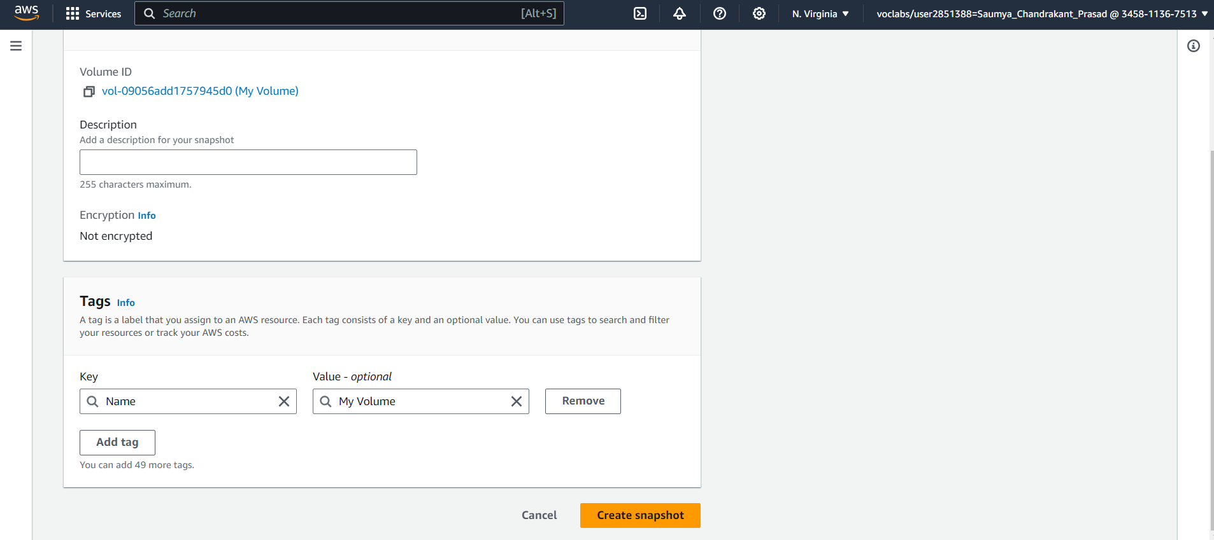

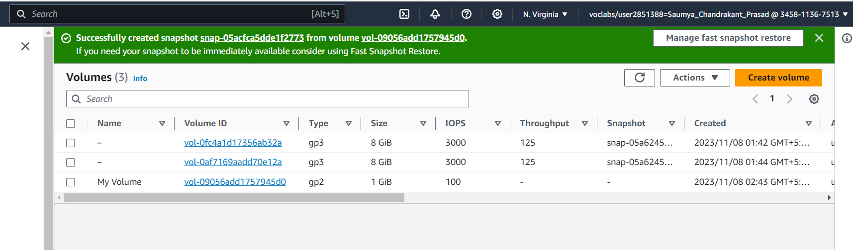

File deleted

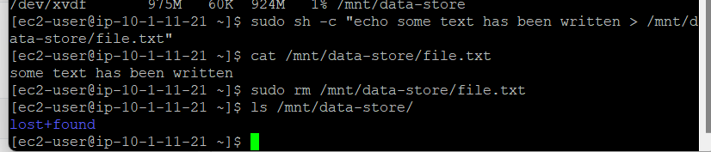

**Task 6 - Restore the Amazon EBS Snapshot**

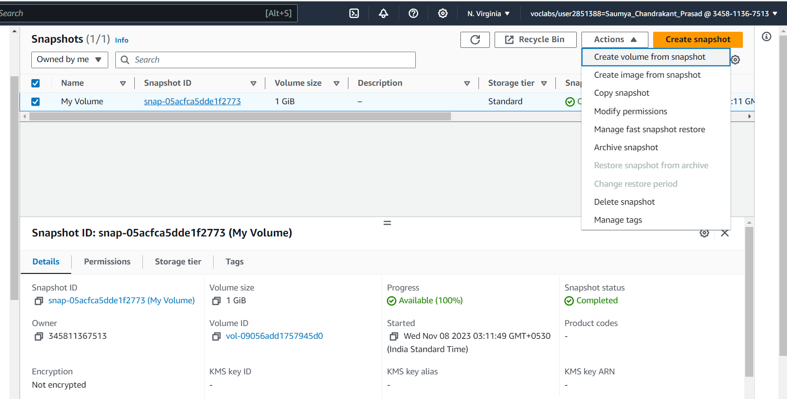

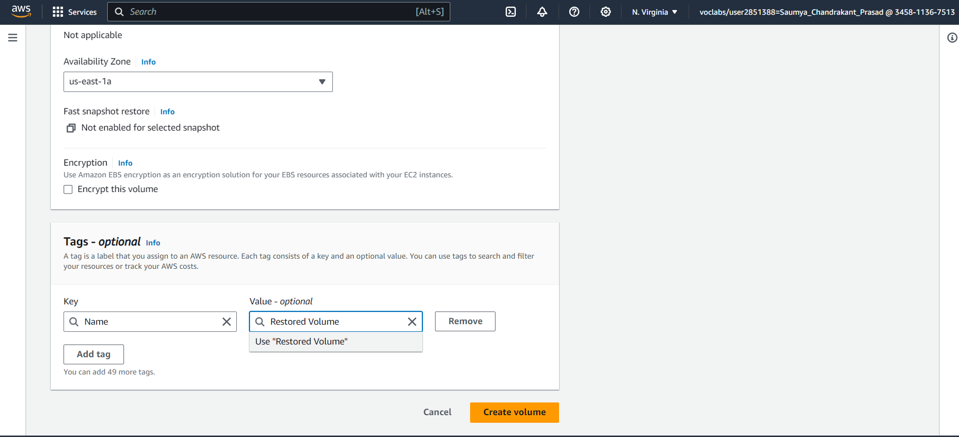

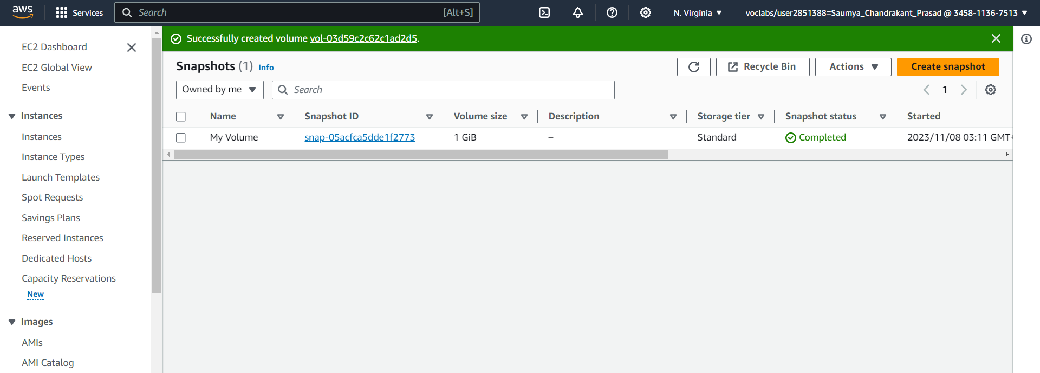

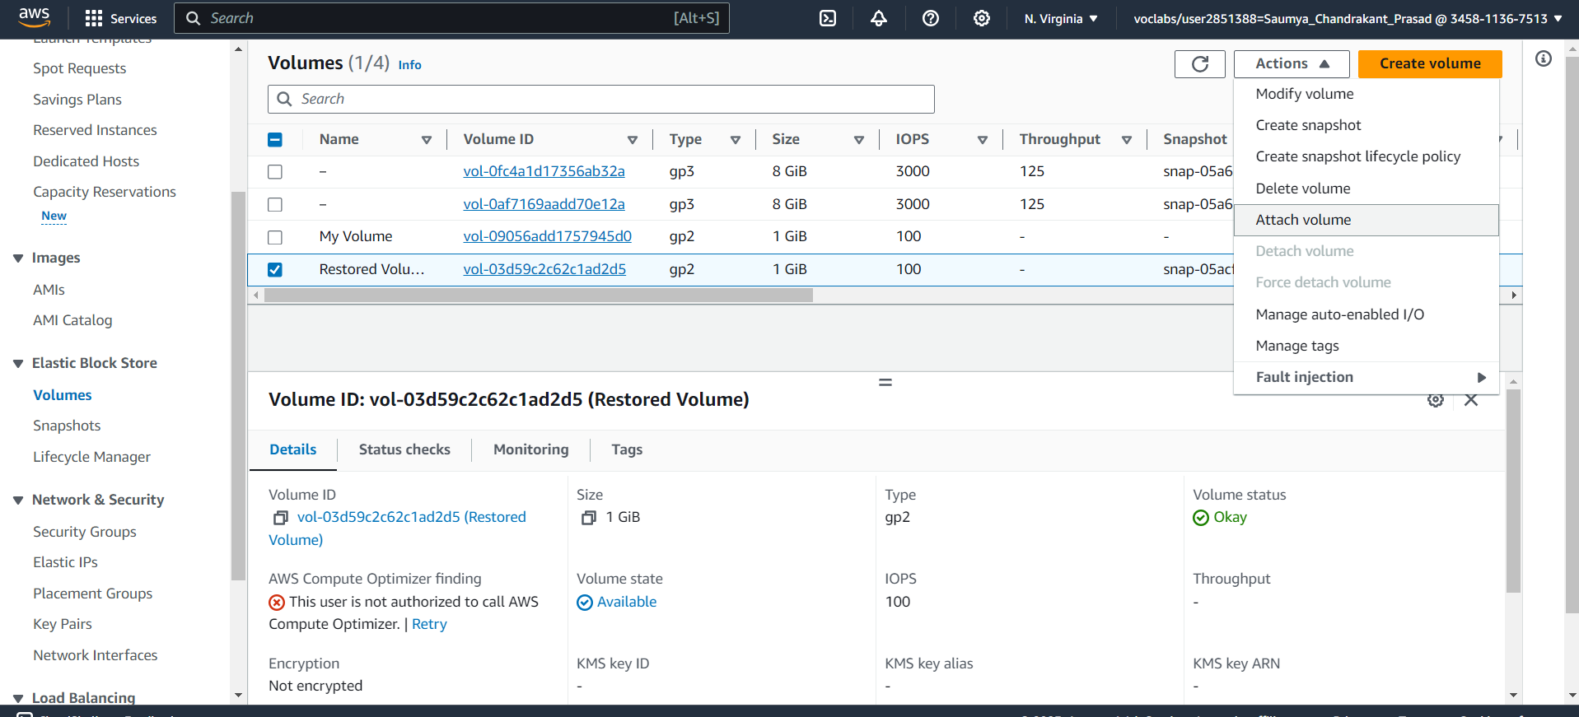

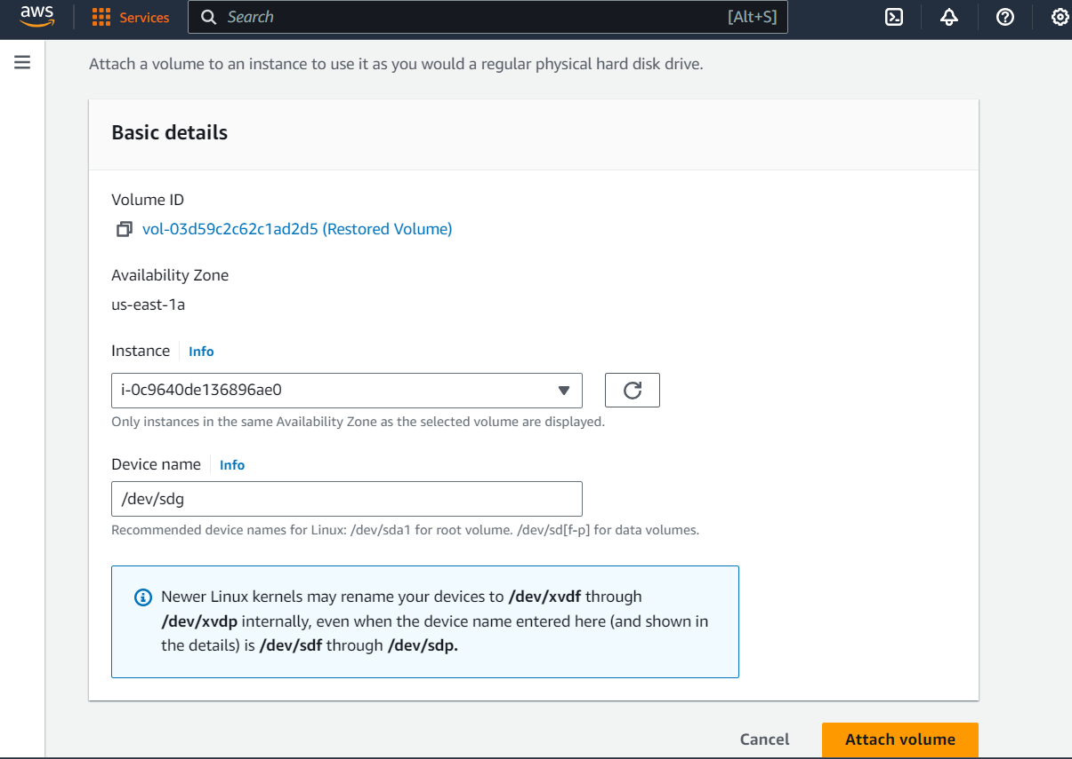

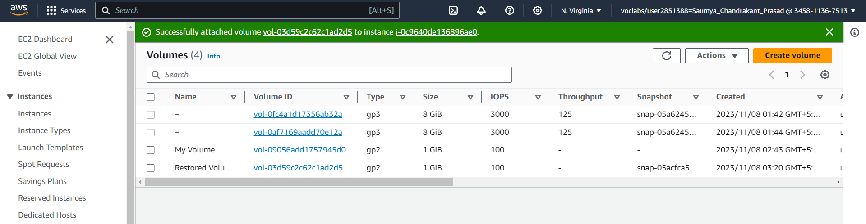

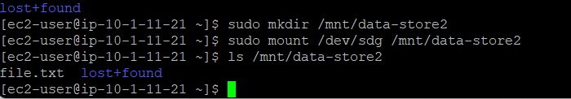

Lab ended

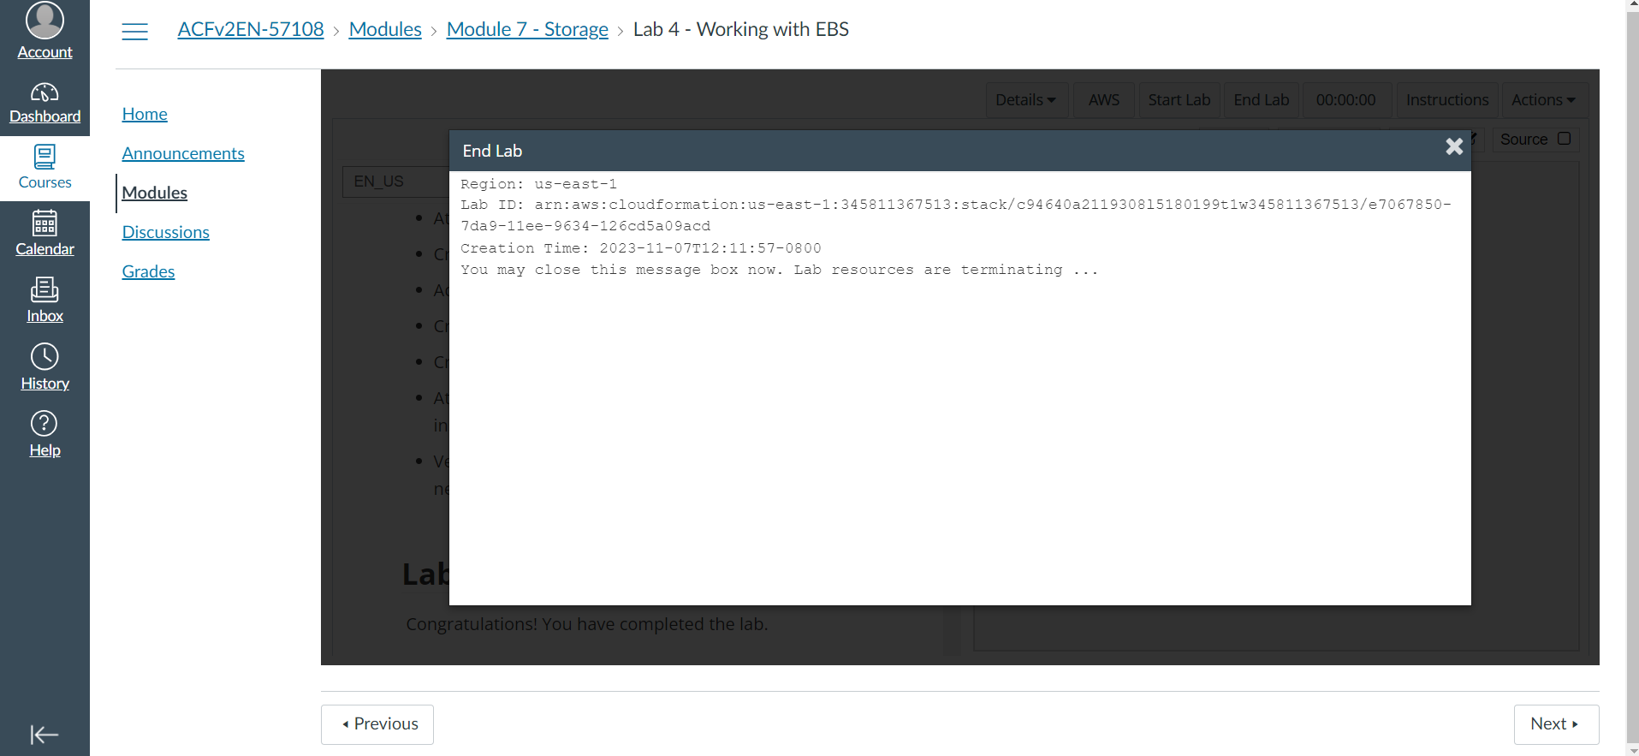

Therefore, in this laboratory session, our emphasis is on Amazon Elastic Block Store (Amazon EBS), which serves as a crucial storage mechanism for Amazon EC2 instances. Throughout this lab, you will gain knowledge on creating an Amazon EBS volume, connecting it to an instance, implementing a file system on the volume, and subsequently creating a snapshot backup.